Implementation of Basic Communication in ROS 2 Using Python
Aadya Prasad
Department of Mathematics and Computing
[MIT,Manipal]
[prasadaadya64@gmail.com]

Abstract—ROS 2 is a framework that helps different programs communicate with each other in a robot. In this taskphase, I learned how to create nodes, publish messages, receive messages, and use custom messages in ROS 2. I completed two problems using ROS 2 Humble and Python. In Question 1, I created a publisher and a subscriber to calculate the longitudinal speed of a wheel using its angular velocity and radius. In Question 2, I created three nodes that work together to check whether a given string is a palindrome. I also learned how to build packages using colcon and view node connections using rqt_graph. These tasks helped me understand the basic working of ROS 2 through practical examples.

I. INTRODUCTION
ROS 2 is used to develop software for robots. A robot may need different programs to perform different tasks. For example, one program may collect information, while another program processes it. ROS 2 allows these programs to communicate with each other.
While working on this taskphase, I learned that each independent program is called a node. Nodes can exchange information through topics, services, and actions. The main aim of this taskphase was to understand these concepts by writing and running simple programs. I worked on two problems. The first problem involved calculating the speed of a wheel, and the second involved checking whether a string is a palindrome. These tasks helped me understand how multiple nodes can work together to complete a task.

II. BASIC CONCEPTS OF ROS 2

A. Nodes
A node is a program that performs a particular task. A ROS 2 system can contain many nodes, and each node can have its own responsibility. For example, in Question 1, one node sends the wheel values, and another node receives them and calculates the speed. In Question 2, three different nodes work together to check a string.

B. Topics
A topic is a channel through which nodes exchange messages. A publisher sends messages to a topic, and a subscriber receives messages from that topic. In Question 1, the publisher sends data through the taskone topic. In Question 2, the nodes use three topics to exchange the input string, the result, and the final answer.

C. Services and Actions
Services allow one node to send a request to another node and receive a response. They are useful for tasks that need a request-and-response process. Actions are used for tasks that take more time to complete. They can provide feedback while the task is running and can also support cancellation. In this taskphase, I mainly used topics for communication between nodes.

D. Custom Messages
A message defines the type of information that nodes exchange. ROS 2 provides standard message types, but sometimes we need to create our own message. For Question 1, I created a custom message named TaskOne. It contains angular velocity and wheel radius. For Question 2, I created a custom message named RT2String. It contains a string field called data.

E. Workspace and Colcon
A workspace is a folder where ROS 2 packages are stored and built. I created a workspace named ros2_ws and stored the packages inside its src folder. Colcon is a tool used to build ROS 2 packages. After building the packages, I sourced the workspace setup file so that ROS 2 could find the packages and use the custom messages.
The workspace contained four main packages: 1. taskone_msg — custom message for Question 1. 2. taskone_nodes — publisher and subscriber for Question 1. 3. rt2string_msg — custom message for Question 2. 4. rt2string_nodes — three nodes for Question 2.

III. QUESTION 1: CALCULATING WHEEL SPEED

A. Objective
The objective of Question 1 was to create a publisher and a subscriber using a custom message. The publisher takes angular velocity and wheel radius as input. The subscriber receives these values and calculates the longitudinal speed of the wheel. The formula used is v = ωr. Here, v represents the longitudinal speed, ω represents angular velocity, and r represents the wheel radius.

B. Custom Message
I created a package named taskone_msg and defined a custom message called TaskOne. The message contains two fields: float32 ang_vel and float32 radius.

C. Publisher and Subscriber. The publisher node is named taskone_publisher. When the program starts, it asks the user to enter the angular velocity and wheel radius. The values are stored in a TaskOne message and published on the /taskone topic. The subscriber node is named taskone_subscriber. It receives messages from the /taskone topic and calculates the speed. I tested with angular velocity 10 rad/s and radius 0.5 m, obtaining v = 5 m/s.
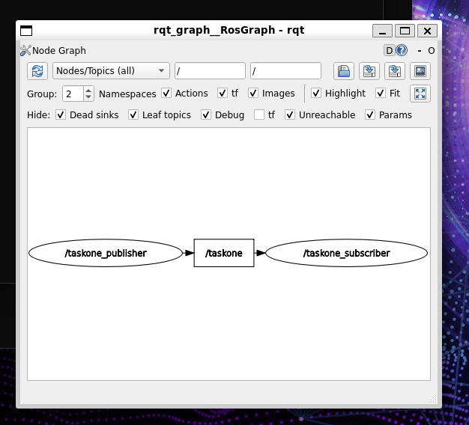

IV. QUESTION 2: PALINDROME CHECKER USING THREE NODES

A. Objective
The objective of Question 2 was to create three nodes that work together to check whether a string is a palindrome. A palindrome is a word or string that reads the same forwards and backwards. For example, AABAA is a palindrome, while HELLO is not. Instead of doing everything in one node, I divided the task into three nodes.
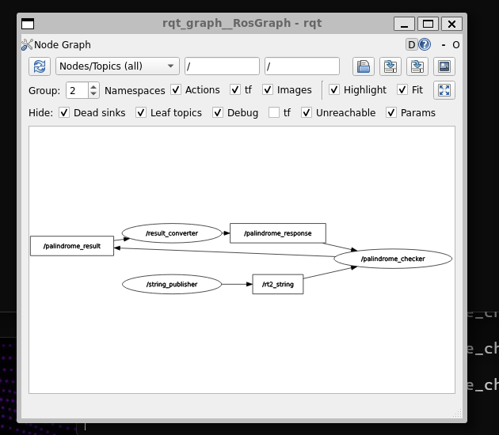

B. Nodes and Communication.

The first node (string_publisher) publishes the input string on /rt2_string. The second node (palindrome_checker) checks if it is a palindrome and publishes 1 or 0 on /palindrome_result. The third node (result_converter) converts the result to Yes or No on /palindrome_response. The second node displays the final answer.

V. TOOLS USED
The following tools were used to complete the taskphase: Ubuntu 22.04 as the operating system, ROS 2 Humble to create nodes and manage communication, Python to write the programs, Colcon to build the packages, ROS 2 command-line tools to check topics and message types, rqt_graph to view the connections between nodes, and Git and GitHub to store and share the source code.

REFERENCES

[1] https://docs.ros.org/en/humble/Installation/Ubuntu-Install-Debs.html
[2] https://docs.ros.org/en/humble/Tutorials/Beginner-CLI-Tools.html
[3] https://www.geeksforgeeks.org/techtips/setup-dual-boot-with-linux-and-windows
[4] https://www.youtube.com/watch?si=BK8k4o9eczblK9Xi&v=F3n0SMAFheM&feature=youtu.be
.

